|  |  |
| --- | --- |
| Harrow Council Logo | |
| REPORT FOR: | HEALTH AND WELLBEING BOARD | |
| Date of Meeting: | 14 January 2020 | |
| Subject: | Public Health Quarterly Update Report | |
| Responsible Officer: | Carole Furlong – Director of Public Health | |
| Public: | Yes | |
| Wards affected: | All | |
| Enclosures: | Public Health Quarterly Report | |

|  |
| --- |
| Section 1 – Summary and Recommendations |
| This report provides updates in the work programmes of the Public Health Team for the second quarter of 2019-20.  **Recommendations:**  This is for information |

Section 2 – Report

See attached report

**Ward Councillors’ comments**

**Financial Implications/Comments**

There are no direct financial implications arising from this report.

The delivery of public health outcomes are funded by a specific ring fenced government grant. The longer term funding of Public Health has yet to be confirmed, with the potential for the service to be funded by business rates. It is not clear what impact, if any, the changes to the funding will have on the level of available resource and future funding decisions will be considered as part of the annual budget setting process.

**Legal Implications/Comments**

Legal note there are no specific implications and risks identified within this Report. Any decisions undertaken in relation to Public Health’s Quarterly Update for quarter 2, will be subject to any relevant governance considerations

**Risk Management Implications**

none

**Equalities implications / Public Sector Equality Duty**

none

**Council Priorities**

The broad work programme of public health is aligned with the council priorities outlined below.

* Building a Better Harrow
* Support those most in need
* Protecting Vital Public Services.
* Delivering a Strong local Economy for All

Section 3 - Statutory Officer Clearance (Council and Joint Reports)

|  |  |  |  |
| --- | --- | --- | --- |
|  |  |  | on behalf of the |
| Name: Donna Edwards | x |  | Chief Financial Officer |
| Date: 19/12/19 |  |  |  |
|  |  |  | on behalf of the |
| Name: Sarah Inverary | x |  | Monitoring Officer |
| Date: 19/12/19 |  |  |  |

|  |  |  |  |
| --- | --- | --- | --- |
|  |  |  |  |
| Name: Paul Hewitt | x |  | Corporate Director |
| Date: 19/12/19 |  |  |  |

|  |  |
| --- | --- |
| Ward Councillors notified: | **NO** |

Section 4 - Contact Details and Background Papers

**Contact:** Sally Cartwright, Consultant in Public Health

Tel 07927548184

**Background Papers**: none

|  |
| --- |
| Quarterly Public Health Report |
|  |

|  |  |
| --- | --- |
| July-Sept 2019 | Quarter 2 |

These quarterly reports will give a snapshot of some of the work that the public health team are involved in each quarter.

Quarterly Public Health Report

Quarter 2

# Introduction

Welcome to quarter 2 public health report. The report outlines key activities within quarter 2 of 19-20 (June – September), within the areas of health improvement, public health commissioning, health intelligence, health care public health, and health protection. This quarter we said goodbye to our GP trainee dr Aliza Dhanji. And Hello to our new one, Dr Samantha Meiring.

## Health Improvement

Health Improvement describes the work to improve the health and wellbeing of individuals or communities through enabling and encouraging healthy lifestyle choices as well as addressing underlying issues such as poverty, lack of educational opportunities and other such areas.

**Oral Health**

Public health has reinvigorated the Harrow Oral Health Steering Group. The group is a multi-displinary approach to improving oral health in Harrow and is chaired by Public Health England. Other partners include representatives from the Local Dentist Committee (LDC), children centres, health visitors and school nurses. The main points of discussion include aligning local dentists with Primary Care Networks and promotioning the additional dental page in the red book. Public Health will be reviewing oral health and older people, where this will be a topic of discussion on what the level of need is and whether this fits into the scope of the Steering Group.

**Dental Epidemiology Survey of 3-year-old children**

Harrow will be taking part in the national Dental Epidemiology Survey of 3-year old children 2019/20 in October. The survey was previously conducted in 2013/14 with varied uptake across London. This year, Harrow PH and the Early Years team have asked settings to participate in the survey. Settings can use their participation as evidence towards achieving their Healthy Early Years award.

**Home Safety**

Public Health have secured 250 home safety packs from the Royal Society for the Prevention of Accidents (RoSPA) to be distributed to families on low income. Evidence shows that more accidents occur in the home than anywhere else and children under the age of five and people over 65 (particularly those over 75) are most likely to have an accident at home. The packs will be distributed to all children centres and to the 0-19 service and accompanied with a short briefing developed by PH on home safety in Harrow. Evaluation forms relating to the practitioners and recipients of the pack will be distributed and collated for feedback to RoSPA.

**Social prescribing**

The social prescribing service in Harrow continues to develop at pace. In quarter 2, we have formed a partnership group between the Primary Care Network Clinical Directors, voluntary sector, CCG, and local authority to steer the borough-wide social prescribing plans. There is a memorandum of understanding between the partners within the group outlining roles and responsibilities to move this programme of work forwards. We have moved forwards with recruitment of the social prescribing manager and the link workers, and have successfully recruited to these roles. The digital provider, which will deliver both a directory of services and a case management system, is mobilising – details of services available for referral, and details for the case management system such as the performance indicators required and referral criteria are being gathered in order to develop the systems. The new service will go live in January, so we will be able to report on how it is going in the next quarterly report.

**Stop smoking**

Within quarter 2 we have advertised for a stop smoking advisor to deliver a small specialist stop smoking service for Harrow. However, this recruitment was challenging due to the post only being 0.6WTE, and we were unsuccessful in this appointment. We are now integrating this role within the substance misuse service reprocurement, to give some efficiencies of delivery and enable better value for money to allow for a whole time equivalent to be recruited as part of the service. In the interim, we have asked the current provider to recruit to the role on a temporary basis to develop the service between now and the new provider coming in in April 2020.

**#AskAboutAsthma Campaign**

Week 38 (third week of September) is always the worst for admissions to A&E for childhood asthma. It is thought that this is because preventer inhaler use over the summer holidays is not as consistent as during the routine of term time and because the children are more likely to be carrying virus and infections. Public Health co-ordinated this campaign in Harrow. A webpage was created, leaflets printed for World Car Free Day and distributed to schools near the air pollution hotspots, cards were printed for school nurses and GPs to give to patients with asthma. A video presentation was uploaded to the TV screens in 25 of the 33 Harrow GP practices. The school nurses promoted the campaign throughout the week and also awarded asthma friendly status the first school to have implemented all the necessary steps (St Joseph’s Catholic Primary School). The service is working to enable all Harrow schools to achieve asthma friendly status.

**Flu vaccination and School Readiness Campaign**

The Director of Public Health has written to all schools to ask for their support for this campaign and ask them to take all possible steps to ensure their school population and vulnerable members of the community are as protected as possible. They have been asked to ensure that all parents / carers receive this information. The letters from the Director of Public Health have all been uploaded on the council website: <https://www.harrow.gov.uk/health-leisure/immunisation/1>. It was made sure that early years settings as well as home schooled families and independent schools were included in this communication.

## Public Health Commissioning

The Public Health Team are responsible for commissioning four programmes: 0-19 Public Health Nursing (health visiting, school nursing and the National Child Measurement Programme); Sexual Health services; NHS Health Checks; and the Drug and Alcohol Treatment and Recovery Service.

### 0-19 Service

### Health Visiting

The service has continued to improve performance. Of particular note is the highest ever percentage of children receiving a two-year review. Some of the highlights of work this quarter were: the service being reaccredited with the UNICEF Level 3 Baby Friendly award for its support for infant feeding. The service contributed to the successful SEND Ofsted inspection by carrying out a comprehensive audit of all its systems and processes for children and families with SEN. It also met with SEN parents at a coffee morning.

The service made contact with the Romanian Community Trust and met with Romanian mums. The feedback was excellent: “The support in Harrow was fantastic for breast feeding. In Romania I wouldn’t have got that support.”

“I appreciated the health promotion in relation to oral health. In Romania there are not messages about brushing teeth when first teeth appear.”

Some of the feedback that has been received from parents about the service they have received recently has been very positive: “The Health Visitor was an absolute gem!” “The Health Visitor was the one who asked about my emotional wellbeing. She was very helpful and supportive.”

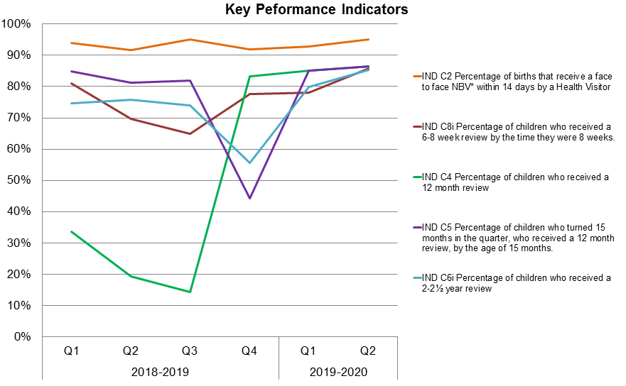

As can be seen from the above table, performance has been improving across the board.

### School Nursing

Vision Screening has been very well received by schools and parents. The final tally for the numbers of pupils who were identified as needing vision correction was 388 children who needed referral to an optician and 54 who needed a referral to the Moorfields Specialist Eye Service at Northwick Park Hospital. An audit was carried out in September 2019 in conjunction with Moorfields Eye Clinic. This found that a) all children who were referred via the optician attended Moorfields Eye Clinic and b) all referrals were appropriate. Anecdotally the feedback has been that this new offer has been very much appreciated by families and schools.

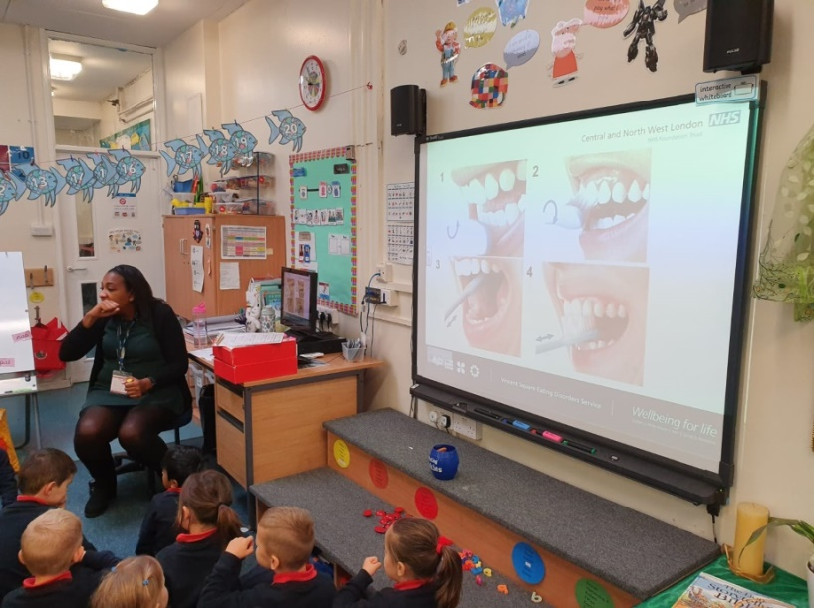

A school nurse leads an oral health session with children in a borough primary school

The service has been promoting a number of public health priorities. There was a focus at the beginning of the new academic year on asthma awareness. They supported the national campaign as set out above. They have also been contacting individual schools about their priorities for the coming year.

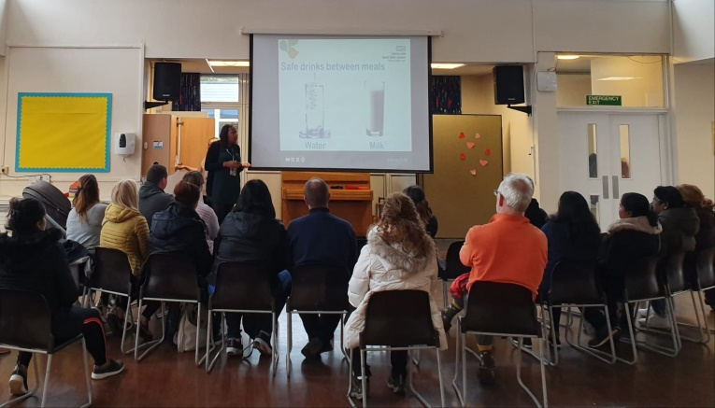

A School nurse talks to parents about the importance of thier child's oral health

Oral health is another major focus for the service given the data around children’s oral health in Harrow. School Nurses have delivered oral health sessions in harrow’s primary schools since the beginning of term. Where possible, sessions are offered to both pupils and parents.

The school nurses have also supported the school holiday activities that the council has organised on the Grange Farm estate. The feedback from parents and families has been very good.

### National Child Measurement Programme

After a very successful first full academic year in 2018-19, the programme of checking children’s height and weight has recommenced for this academic year.

### NHS Health Check programme

Since the new contract commenced on 1 April 2019 there has been a slower start to the programme in the new financial year than was hoped. We are still expecting to achieve the target of 20% invites by the end of the year but it is taking the service longer than expected to sign some of the larger GP practices up to deliver the programme again. It is a positive sign that one of the largest has recently started to engage more fully.

The focus remains increasing the number of invitations, increasing uptake of NHS Health Checks and improving data quality so that it is easier to measure impact.

The following graph shows Healthckeck performance by GP practice with cumulative activity data for Q1 and Q2 2019-20.

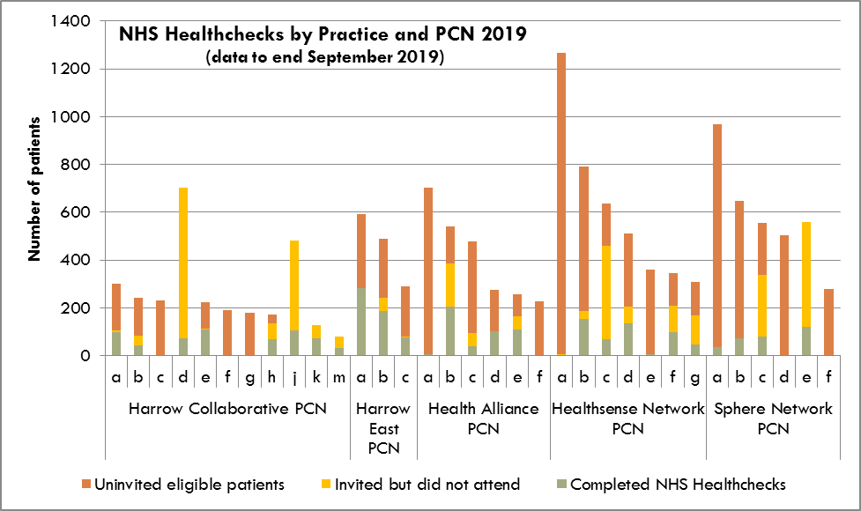

Please note that where completed NHS Health Checks exceed the number of invites this is usually as a practice is carrying out opportunistic NHS Health Checks i.e. when a patient has come to the practice for another issue. At the end of the year we ensure that if there is no invite attached to a completed NHS Health Check this is counted as an invite.

**Substance misuse**

Throughout quarter 2 we have been preparing to reprocure the adults substance misuse service. The reprocurement will continue throughout the next quarter, and the new provider will be in place for the new financial year in April 2020.

## Health Intelligence

Health Intelligence is the sub-speciality of public health that deals with data, performance indicators, outcome measurements, evidence of effectiveness, needs assessments and profiles.

### Joint Strategic Needs Assessment

The second installment, Age Well is being developed . In the UK, the number of people aged 65 and over is projected to rise by nearly 50% in the next 20 years. Harrow has one of the highest proportion of those aged 65 and over amongst its neighbouring boroughs, at 15.7% higher than London at 11.6%.

In the future, there is a further projected increase in those over the age of 65 of around 22% in Harrow by 2025. The general increases that we are seeing in the older population groups are important to highlight for the effective planning and provision of appropriate health services within primary and secondary care, as well as those services offered in the community, as there is evidence to show that these age groups represent a greater demand for care, and use a greater proportion of health services compared to other age groups.

As people age, their life expectancy actually increases. Each year you live means that you have survived all sorts of causes of death. So your life expectancy at 65 is not the same as it is was at birth. Although both men and women in Harrow live longer than they do in, London, and England, a greater proportion of their life is spent with a disability or a limiting persistent illness

As life expectancy continues to increase it is important to ask whether these additional years in life are being spent in favorable health states or prolonged poor health and dependency.

The chapters to be presented in the Age Well section of the JSNA, are :

* Summary of key Indicators
* Demographic of the aging population in Harrow, i.e. age, sex, ethnicity with a summary report on projected increases
* Life Expectancy and Healthy Life Expectancy
* Adult Social Care – data of key performing indicators within this area of how Harrow compares, along with a strategic overview
* Dementia- current prevalence and implications for the population of Harrow
* Diabetes-current prevalence and implications for the aging population of Harrow
* Other Long term conditions – including Cancer, COPD, CVD, and MSK conditions
* End of Life Care, including Carers

The JSNA Online tool, is a web-based tool which allows ongoing updates as and when new data is publishesd and reports are developed, hence the JSNA programme is a rolling progranne that will be delivered over the course of the year. The tool can be viewed [**here**](https://harrow.maps.arcgis.com/apps/MapJournal/index.html?appid=18bc27b967a6439886540cde6b8a7ad1): Or “google” Harrow JSNA and it will take you to the right page for the online tool.

## Health Care Public Health

**Population Health Management**

We have been developing an approach to population health management in Harrow, to support and inform the integrated care programme.

More information on this is given in the integrated care report.

## Health Protection

Quarter 2 saw the re-establishment of a health protection forum for Harrow. This will be a quarterly meeting, with attendees across partners including Public Health England, NHS England, and local agents who hold health protection responsibilities such as in emergency planning and delivery of immunisations.

The first meeting focused on flu and saw reports from Public Health England health protection team, and from NHS England on immunisations uptake.

Locally, letters have been sent out recently to primary schools via the gold bulletin to distribute to all parents regarding immunisations. This is to remind them of the vaccination schedule and to check whether their child is up to date with their vaccinations – particularly highlighting the importance of MMR due to increasing cases and outbreaks of measles across London.

Next year, we will build this into work programmes earlier so that letters can be sent prior to new reception children starting school to remind parents to ensure they are up to date with the preschool booster immunisations (which includes the second MMR).

## Coming up in Quarter 3

The next quarterly report will include a review of the use of the public health grant in 2018-9 and the results of the re-procurement of the adult substance misuse service and a a look at winter wellness issues.